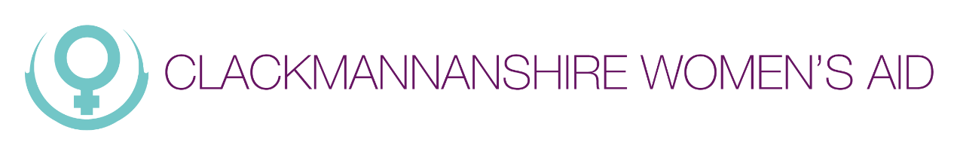

Equal Opportunities Monitoring Form
Clackmannanshire Women’s Aid is committed to promoting quality of opportunity. You are not required to answer any or all of the questions, but it would assist us in monitoring the effectiveness of our recruitment and selection policy.

The information you provide is for monitoring purposes only and will not be used as part of the recruitment and selection process. This section will be removed before the shortlisting process. The information will be treated in the strictest confidence.

If returning by post, please return in a sealed envelope marked confidential.

Post Applied For

Age (please tick)
- Under 20
- 20-30
- 31-40
- 41-50
- 51-60
- Over 61
- Prefer not to say

Ethnic Origin

A White
- British
- Irish
- Any other White background (please specify)

B Mixed
- White and Black Caribbean
- White and Black African
- White and Asian
- Any other mixed background (please specify)

C Asian or Asian British
- Indian
- Pakistani
- Bangladeshi
- Any other Asian background (please specify)

Black or Black British
- Caribbean
- African
- Any other Black background (please specify)

D Chinese or other ethnic group
- Chinese
- Any other Chinese background (please specify)

E Other Ethnic background
- Other Ethnic background

F Prefer not to say
- Prefer not to say

Religion or Religious Belief
- Buddhist
- Christian
- Hindu
- Jewish
- Muslim
- Sikh
- Other
- Prefer not to say

Do you consider yourself disabled?
- Yes
- No
- Prefer not to say

Sexuality
- Bisexual
- Heterosexual
- Lesbian
- Other
- Prefer not to say

